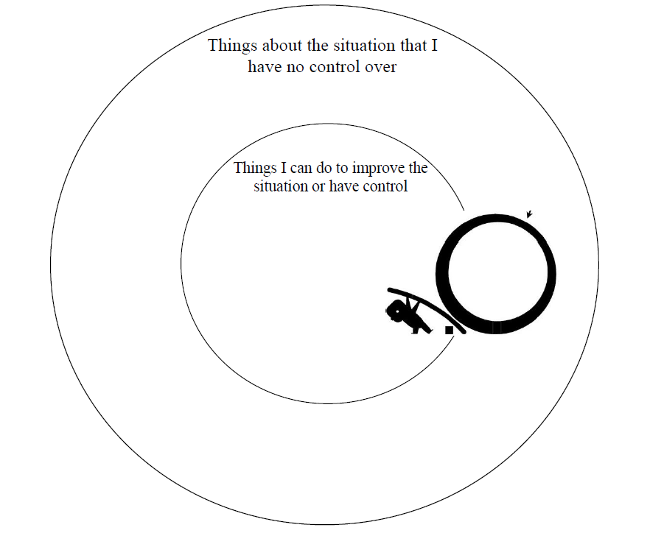
SITUATION: Trauma, Apathy, Skill Deficits, Low Motivation, Poverty, Stress, Low Self-Worth, Interpersonal Conflict, Violence, Bullying, Etc.
How do I LEVERAGE influence and control I have to positively affect the environment and people around me?
CAN’T control/influence
CAN control/
influence *

